PRISM – Day 7 Work Report
Day 7: Quotation Ingestion & Procurement Intelligence
1. Day 7 Objective
The main objective of Day 7 was to design the quotation ingestion and procurement intelligence flow for PRISM – Procurement Risk Intelligence & Supplier Management.
The focus was on understanding how supplier quotations can be uploaded, how AI can extract important procurement information, how the extracted data is validated and stored, and how the structured information can support quotation comparison and procurement KPIs.
Main workflow:
Quotation Upload → AI Extraction → Data Validation → Procurement Data → KPI Calculation → Quotation Comparison → Procurement Dashboard

2. Quotation Ingestion
What is Quotation Ingestion?
Quotation ingestion is the process of receiving supplier quotation documents and converting their information into structured procurement data that can be processed by the system.
In PRISM, suppliers may provide quotations in different formats. Instead of requiring procurement users to manually enter every field, the system can accept the quotation and process its contents.
PRISM Quotation Ingestion Flow
Supplier Quotation
↓
Upload Document
↓
Document Processing
↓
AI Extraction
↓
Structured Procurement Data
Information targeted for extraction:
- Supplier Name
- Product / Component
- Quantity
- Unit Price
- Taxes
- Delivery Terms
- Payment Terms
- Warranty
- Commercial Conditions

3. AI-Based Quotation Extraction
AI-based extraction converts information from an unstructured quotation document into structured fields.
For example:
Supplier ABC offers 5,000 ECU units at ₹125 per unit, with delivery in 20 days, payment within 30 days and a one-year warranty.
The system can convert this into:
Field | Extracted Value
Supplier | ABC
Product | ECU
Quantity | 5,000
Unit Price | ₹125
Delivery | 20 days
Payment Terms | 30 days
Warranty | 1 year
The extracted information can then be used for comparison, analysis and decision support.
Important Principle
AI extraction should not be treated as automatically correct. Extracted information must go through validation before it is stored as trusted procurement data.

4. Class Diagram
A Class Diagram represents the main entities in the system, their attributes and relationships.
Supplier
Supplier
----------------
supplier_id
name
contact
capacity
status
Product / Component
Product
----------------
product_id
name
category
specification
RFQ
RFQ
----------------
rfq_id
quantity
required_date
status
Quotation
Quotation
----------------
quotation_id
supplier_id
product_id
rfq_id
quantity
unit_price
tax
delivery_terms
payment_terms
warranty
commercial_conditions
status
Main Relationships
Supplier
|
| provides
↓
Product / Component
|
| requested through
↓
RFQ
|
| receives
↓
Quotation
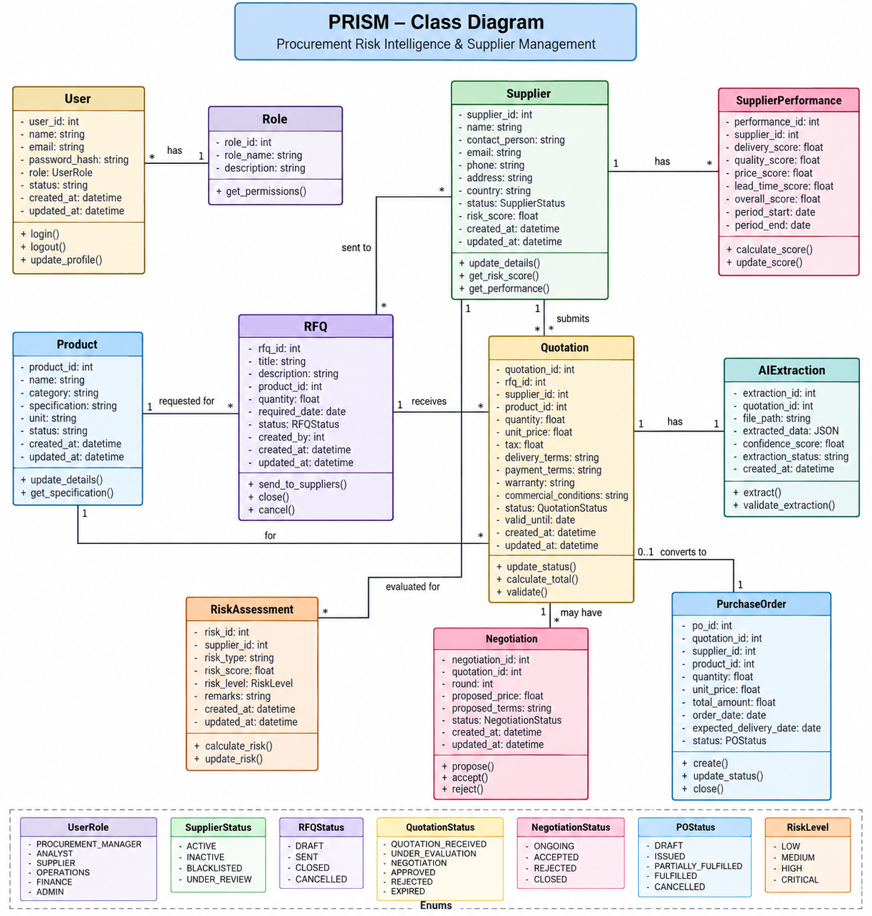

5. Module Design
Module design divides PRISM into logical functional areas so that each part has a clear responsibility.
PRISM
|
+------------------+------------------+
| | |
↓ ↓ ↓
Supplier Product Procurement
Management Management Management
|
↓
Quotation Management
|
↓
AI Quotation Extraction
|
↓
Procurement Intelligence
The broader PRISM AI workflows are coordinated through the Master Procurement Agent:
- Planning & Inventory
- Supplier Intelligence
- Risk & Monitoring
- Decision & Recommendation
- Negotiation

6. CRUD Operations
CRUD stands for:
- Create
- Read
- Update
- Delete
Supplier CRUD
Create → Add supplier
Read → View supplier information
Update → Modify supplier details
Delete → Remove invalid or draft records
Example REST APIs:
POST /suppliers
GET /suppliers
PUT /suppliers/{id}
DELETE /suppliers/{id}
Quotation CRUD
Create → Upload/create quotation
Read → View quotation and extracted data
Update → Correct or revise quotation information
Delete → Remove invalid quotation records

7. Validation Flow
Validation ensures that extracted quotation information is complete, meaningful and suitable for storage.
Quotation Upload
↓
AI Extraction
↓
Extracted Fields
↓
Validation
↓
+-----------+
| |
Valid Invalid
| |
↓ ↓
Store Manual Review
Validation can check:
- Supplier identification
- Product identification
- Quantity validity
- Numeric price values
- Delivery information
- Required commercial terms
- Duplicate quotations
- Missing fields
For example, if payment terms are not detected:
Payment Terms
↓
Not Detected
↓
Manual Verification Required
This prevents incomplete AI output from being treated as reliable procurement information.

8. Procurement KPI & Dashboard Flow
Validated quotation information can be used to calculate procurement KPIs.
Important KPIs identified for Day 7 include:
- Price Variance
- Historical Price Difference
- Supplier Score
- Potential Savings
- Delivery Performance
- Negotiation Opportunity
Example: Price Variance
If:
Historical Price = ₹100
Current Price = ₹120
Then:
Price Difference = ₹20
Price Variance = 20%
Dashboard Flow
Procurement Data
↓
KPI Calculation
↓
Quotation Comparison
↓
Procurement Intelligence Dashboard

9. Gaussian Mixture Model (GMM)
What is GMM?
Gaussian Mixture Model (GMM) is an unsupervised machine learning technique used for probabilistic clustering.
GMM assumes that data can be represented as a mixture of multiple Gaussian probability distributions.
Unlike hard clustering, GMM provides a probability of belonging to each cluster.
Example:
Supplier A

Cluster 1 → 80%
Cluster 2 → 15%
Cluster 3 → 5%
This is known as soft or probabilistic clustering.
Possible PRISM Application
GMM can potentially identify supplier behaviour patterns using signals such as:
- Delivery delay
- Lead-time variation
- Quality rejection
- Quantity shortage
- Price variation
- Capacity behaviour
For example:
Supplier Data
↓
GMM
↓
+-----------+------------+---------------+
| | | |
Stable Variable Deteriorating
Suppliers Suppliers Suppliers
This can be considered a supporting analytical technique for supplier intelligence and should not be treated as the final supplier-risk decision by itself.

10. GMM vs K-Means
K-Means | GMM
Hard clustering | Soft / probabilistic clustering
Assigns a point to a cluster | Gives probability for each cluster
Uses distance to centroids | Uses probability distributions
Simpler clustering approach | More flexible cluster representation
Memory Point
K-Means → Which cluster?
GMM → How likely is each cluster?

11. BFS / DFS – DSA Learning
Day 7 also covered BFS / DFS through:
- LeetCode #733 – Flood Fill
- LeetCode #200 – Number of Islands
BFS and DFS are graph traversal techniques used to explore connected elements.
For PRISM, the concept can be related to traversing connected procurement relationships:

Supplier
↓
Product
↓
RFQ
↓
Quotation
↓
Purchase Order
This is primarily a DSA learning connection rather than a claim that BFS/DFS is a core PRISM intelligence algorithm.

12. Day 7 Project Work – Quotation Comparison
The team reviewed the complete quotation comparison flow:
RFQ Creation
↓
Supplier Selection
↓
Quotation Upload
↓
AI Data Extraction
↓
Validation
↓
Quotation Comparison
The comparison can consider:
- Price
- Quantity
- Delivery terms
- Payment terms
- Quality/performance information
- Commercial conditions
- Historical pricing where available
The objective is to provide procurement users with structured information for better supplier evaluation and decision support.

13. Day 7 Review
Quotation Ingestion Review
Key question:
Can the system accurately ingest supplier quotations and extract supplier name, product, quantity, price, taxes, delivery terms, payment terms and commercial conditions?
Quotation Comparison Challenge
Demonstration flow:
RFQ Creation → Supplier Selection → Quotation Upload → AI Data Extraction → Quotation Comparison
Test cases:
- Duplicate quotations
- Missing fields
- Different quantities
- Price variations
- Incomplete commercial conditions

14. Key Learning
The main Day 7 concepts form one connected procurement intelligence workflow:
Quotation Upload
↓
AI Extraction
↓
Validation
↓
Structured Procurement Data
↓
KPI Calculation
↓
Quotation Comparison
↓
Procurement Dashboard
Day 7 connected system design concepts such as Class Diagrams, Module Design, CRUD and Validation with AI-based quotation processing and procurement analytics.
GMM introduced probabilistic clustering as a possible supporting technique for identifying supplier behaviour patterns, while BFS/DFS strengthened understanding of connected data traversal.

15. Day 7 Key Takeaway
Day 7 focused on transforming unstructured supplier quotations into validated, structured procurement information that can support KPI calculation, supplier comparison and procurement intelligence.

